CLOUD COMPUTING LAB

Submitted By: Zunaira Khatoon
Submitted To: Engr. Muhammad Shoaib
Roll No: BSE-2023-074
Section: V-B
LAB 3

Task 1 – Handling Local and Remote Commit Conflicts (Pull vs Pull --rebase)
STEP1: remote_edit.png
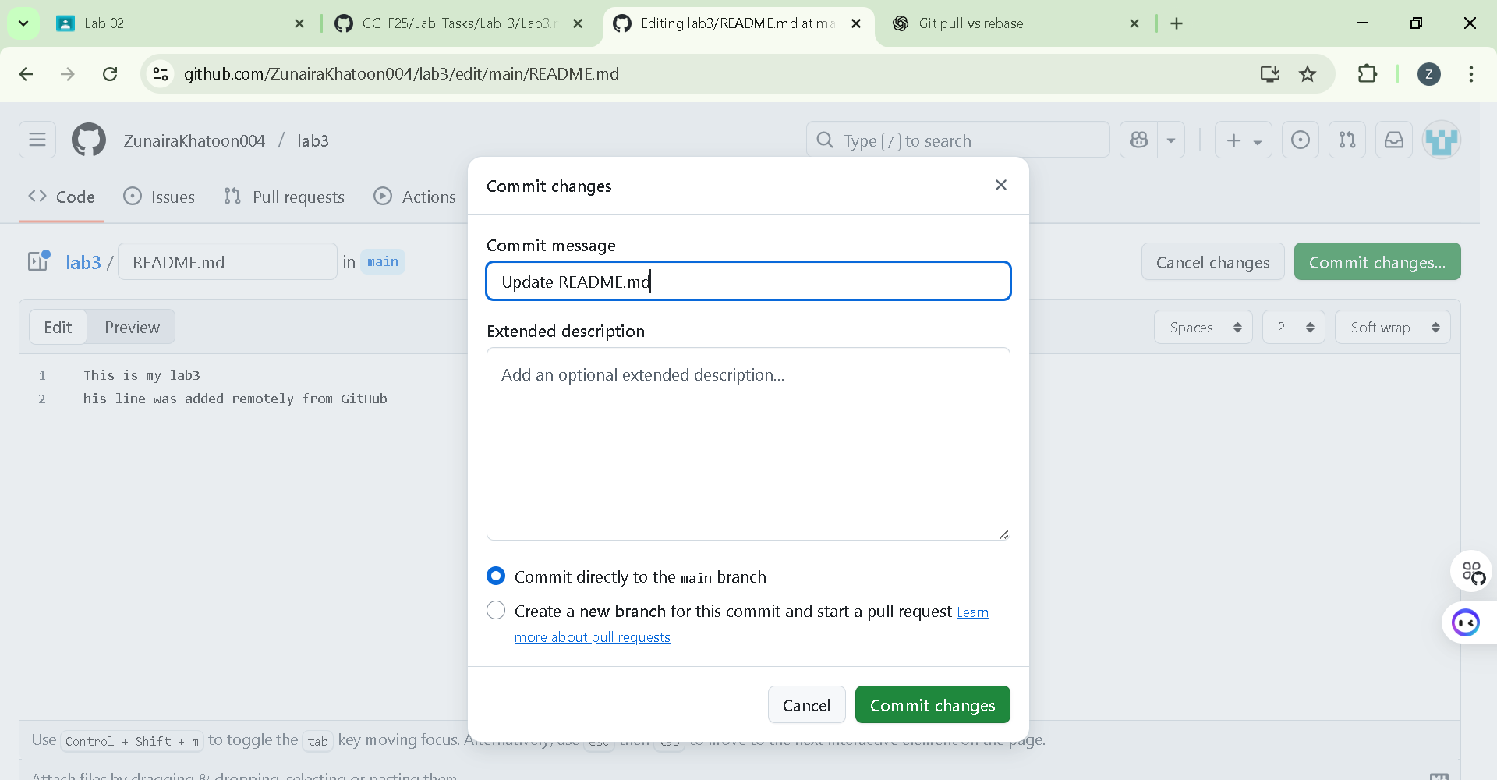
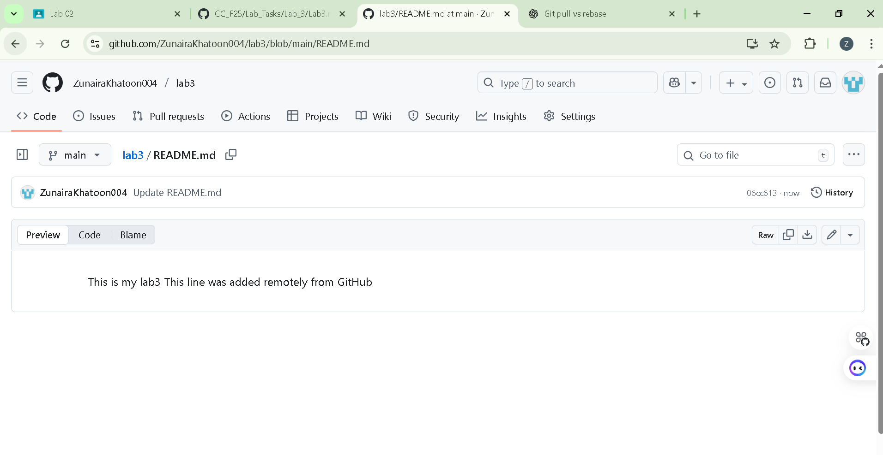
STEP2:
Cloning
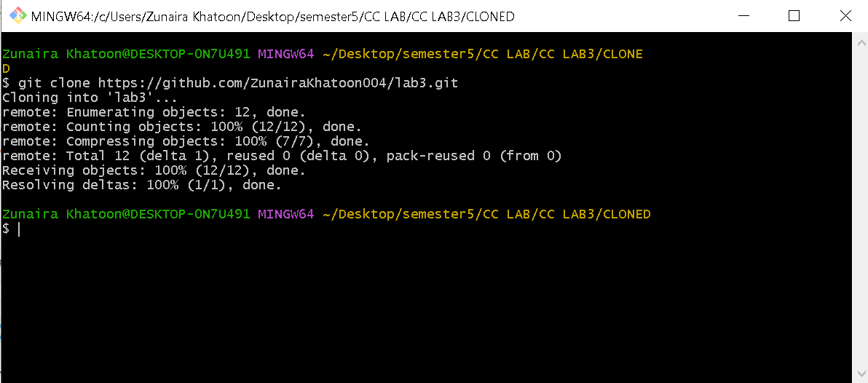
Updating readme locally
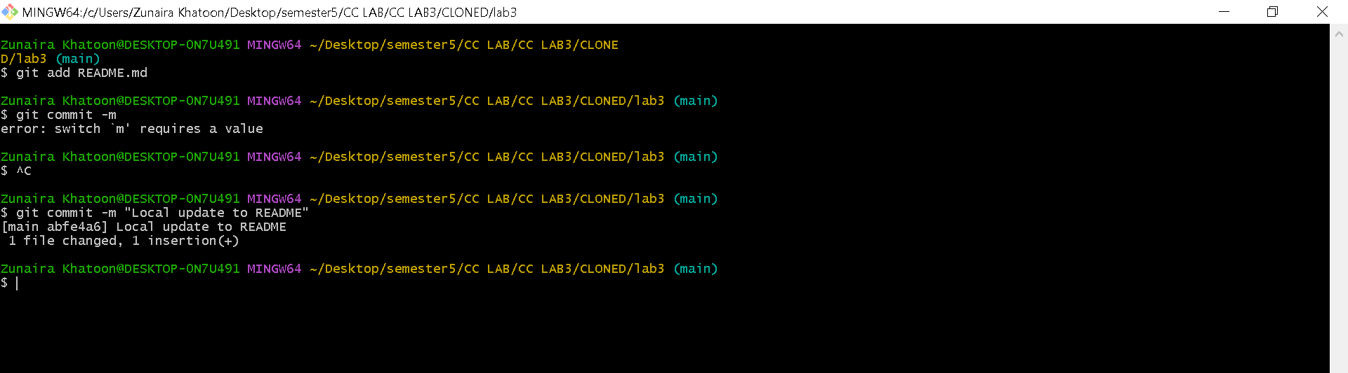
Step 3 — Try to push your local commit to the remote repository
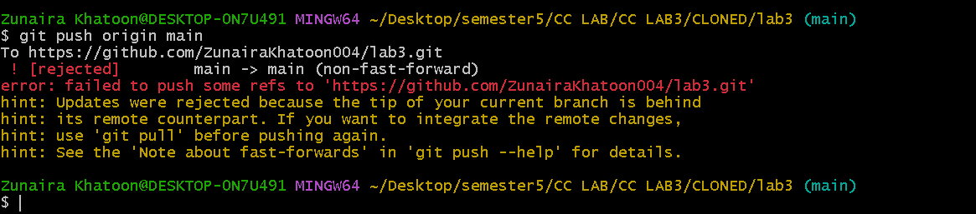
Step4
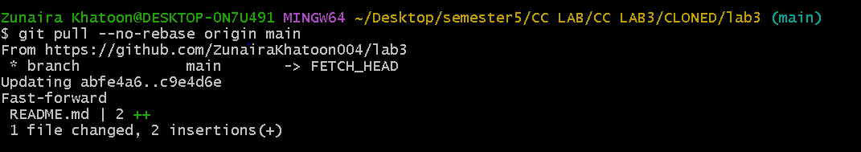
Step5
Step6
Remote change
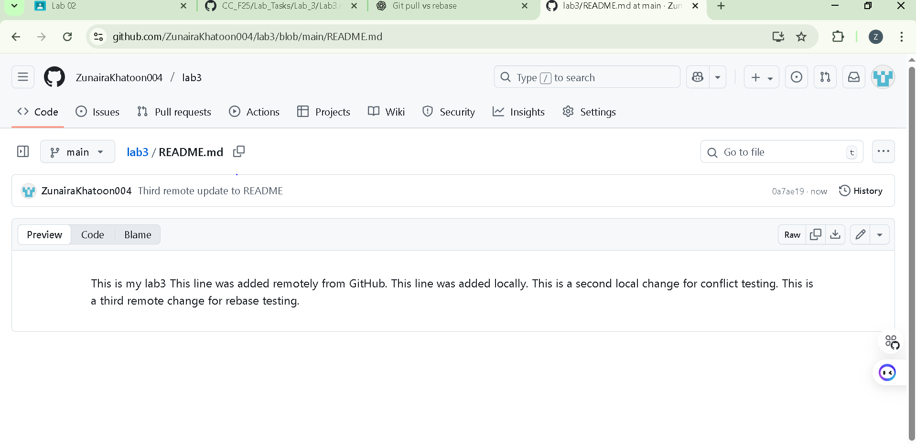
Local change
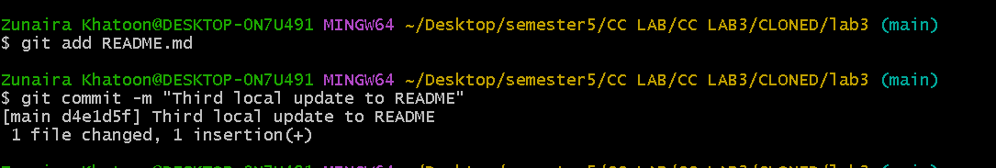
Rebase comands
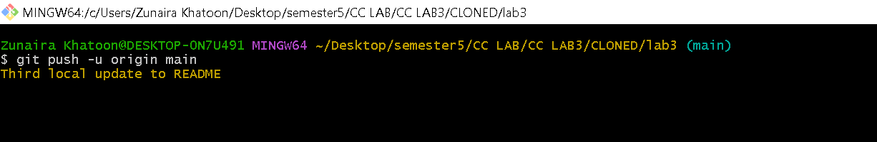
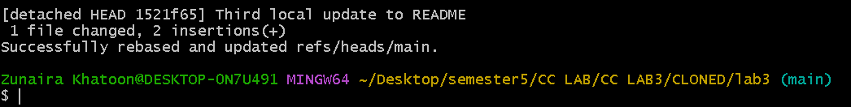
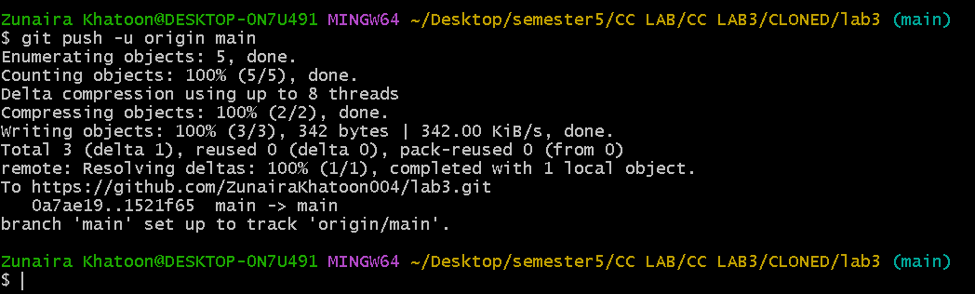

Task 2 – Creating and Resolving Merge Conflicts Manually
Step1
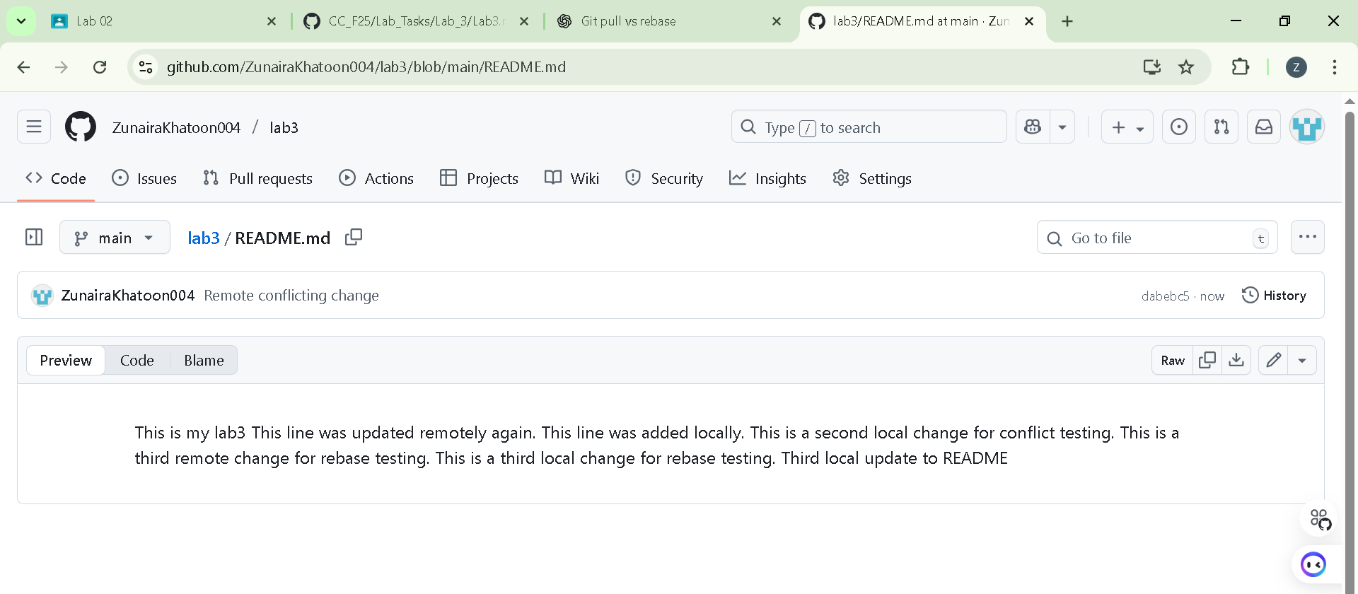
Step2
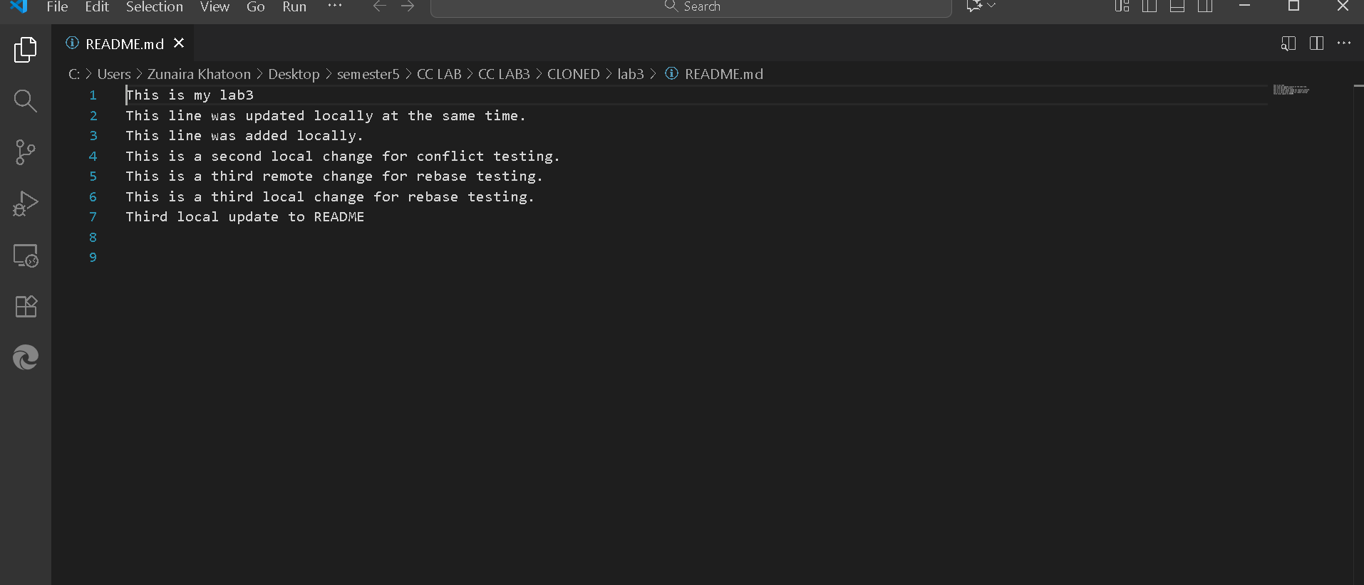
Step3
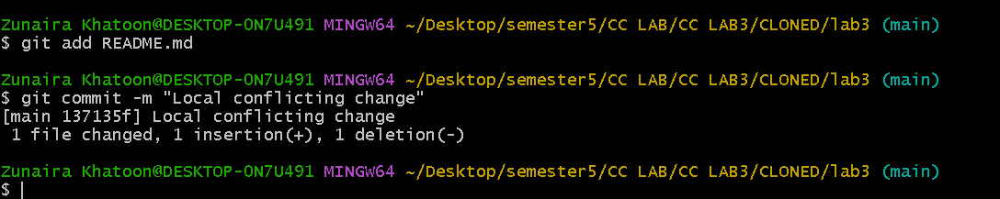
Step4
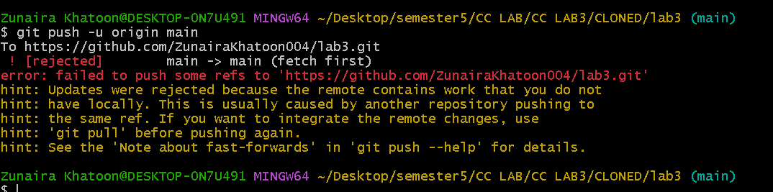
Step5
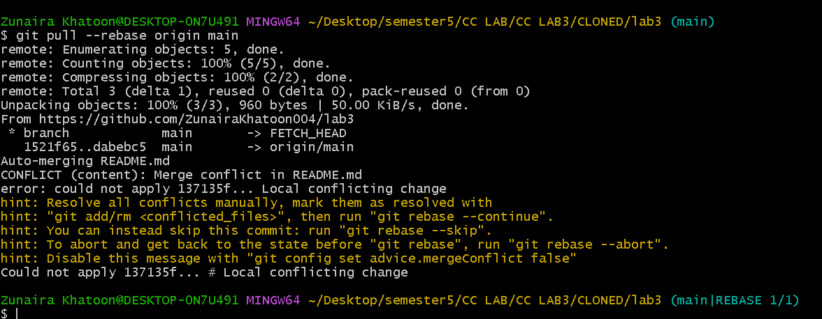
Step6
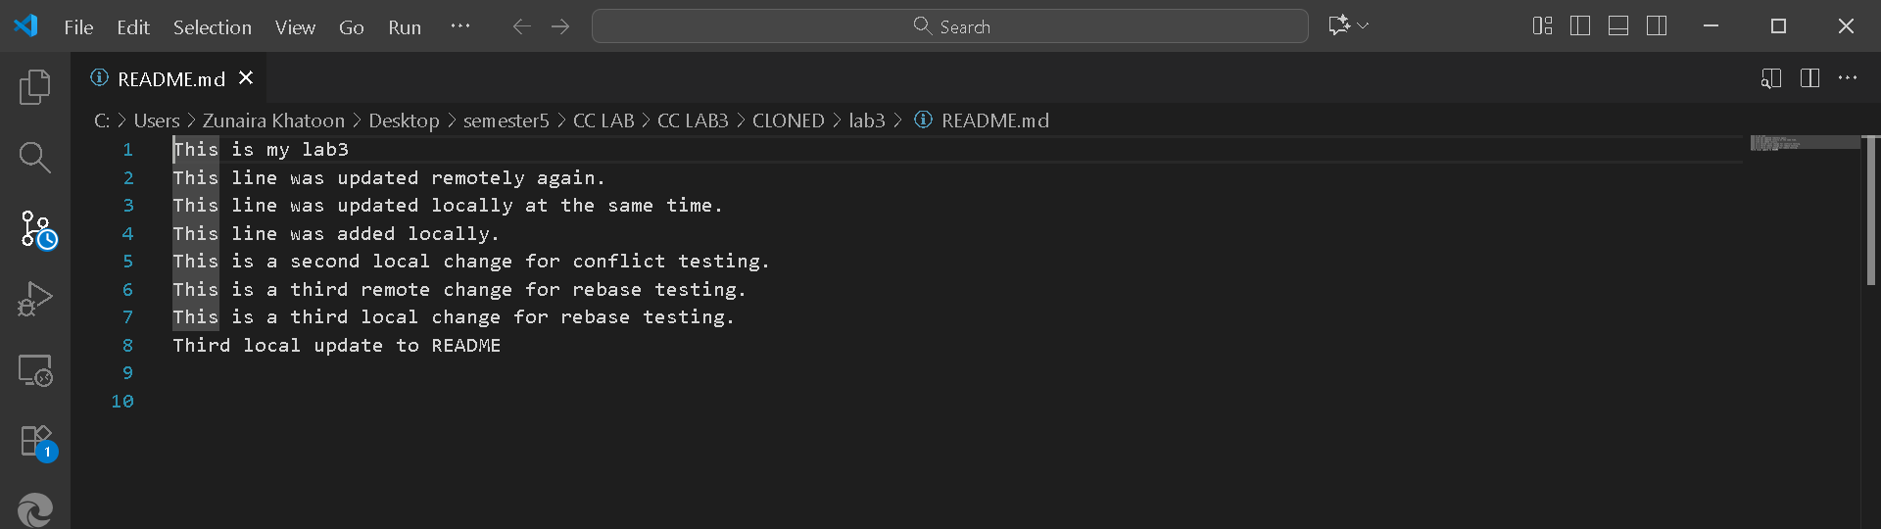
Step7
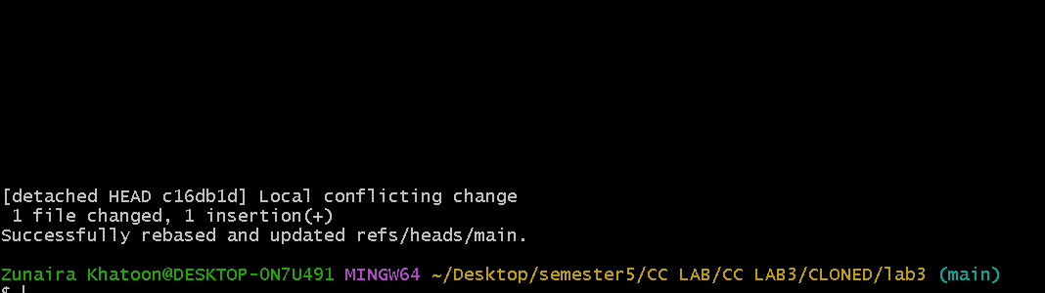
Step8
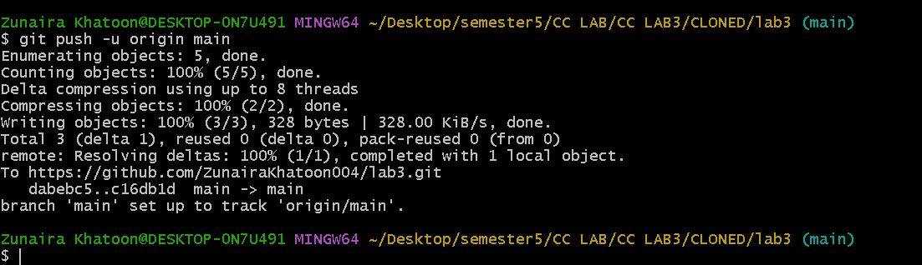
Task 3 – Managing Ignored Files with .gitignore and Removing Tracked Files
Step1
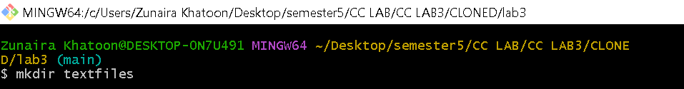
Step2
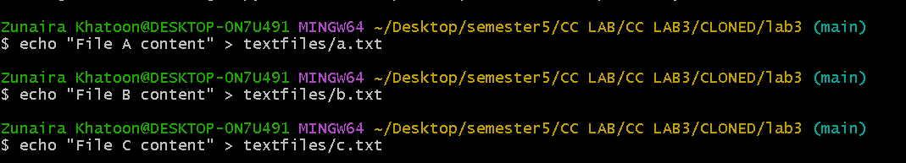
Step3
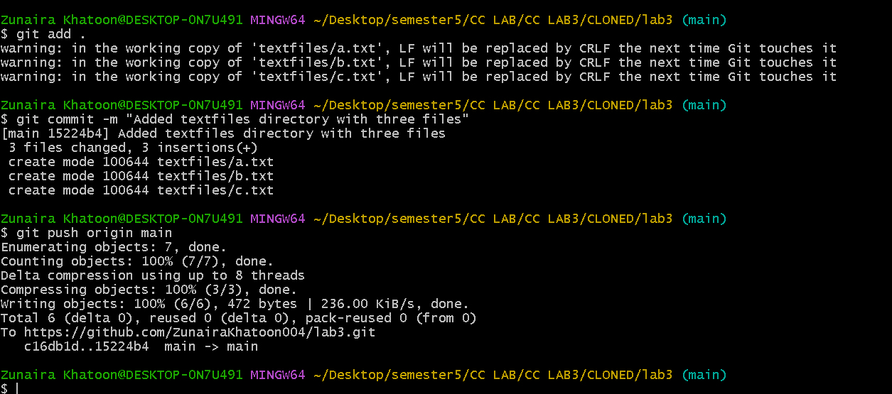
Step4 & 5
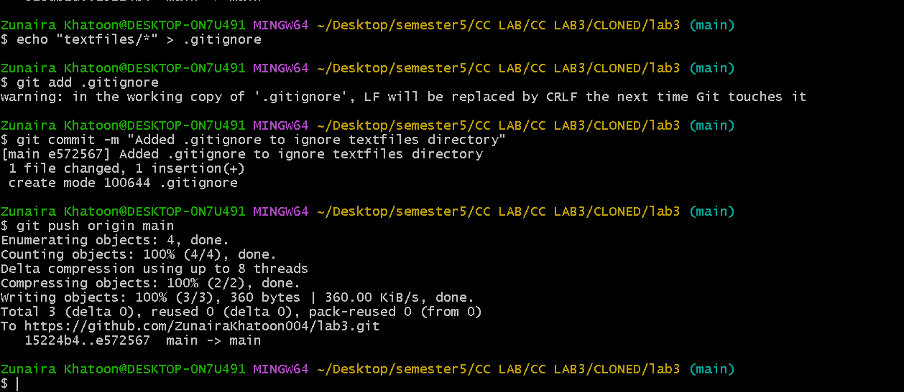step6
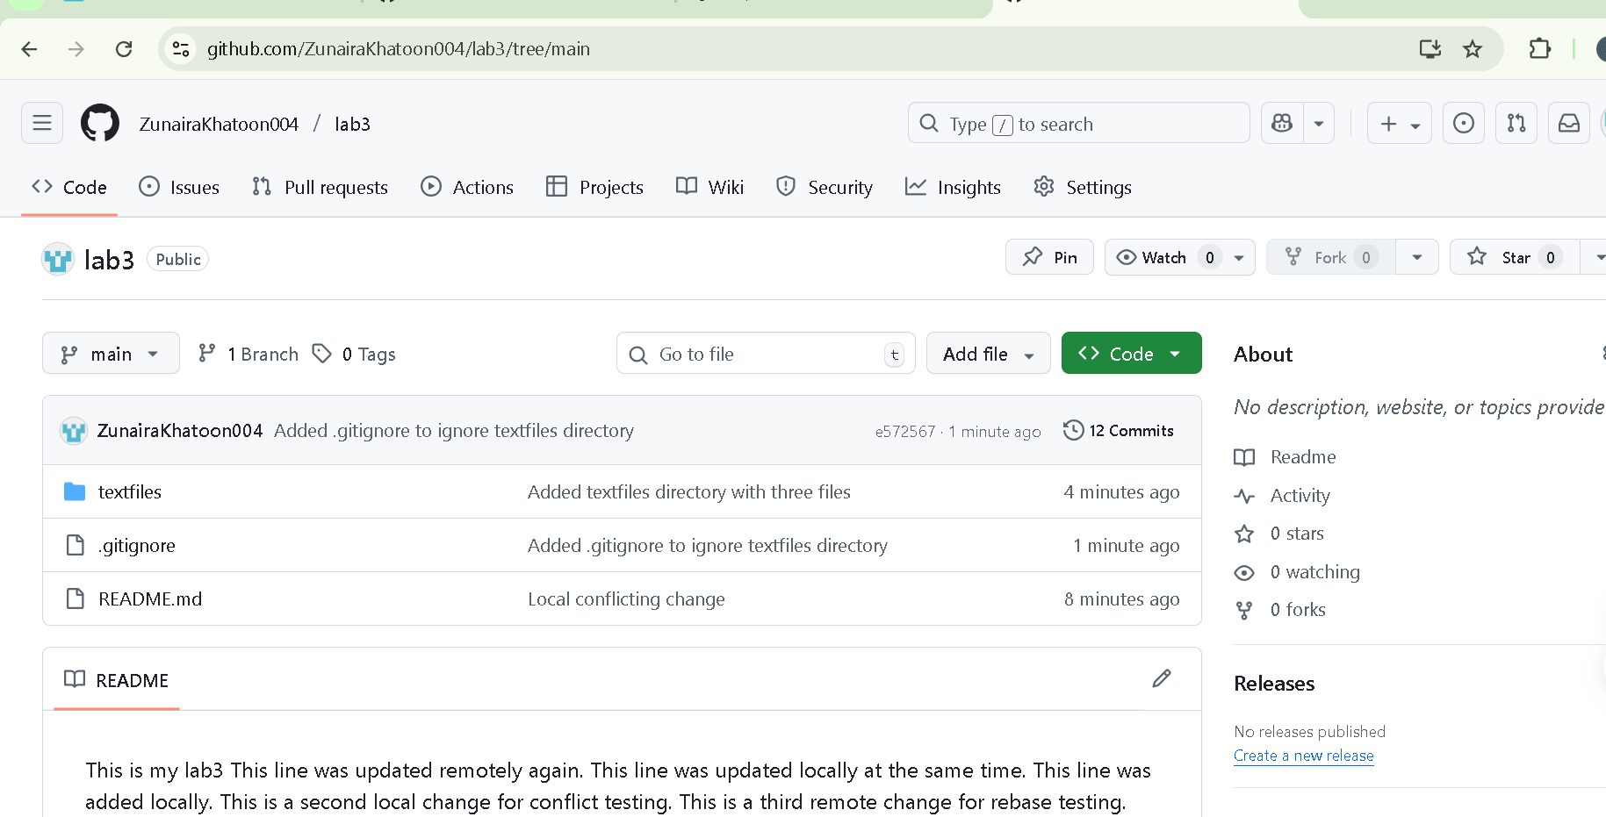
Step 7&8
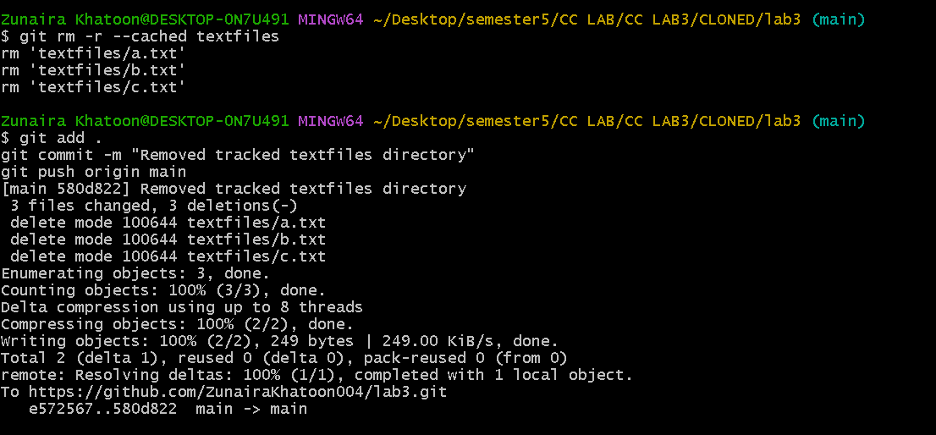
Step9
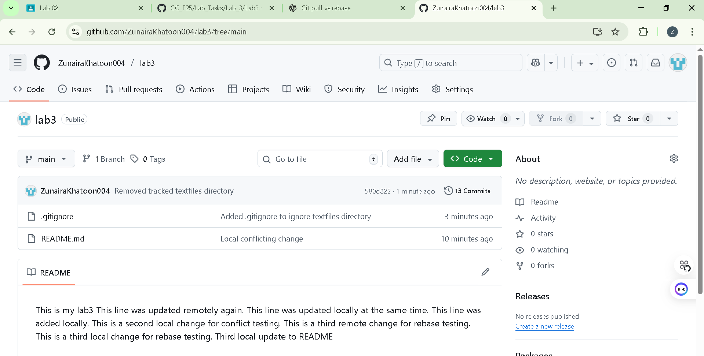
Task 4 – Create Temporary Changes and Use git stash
Step1
Step2
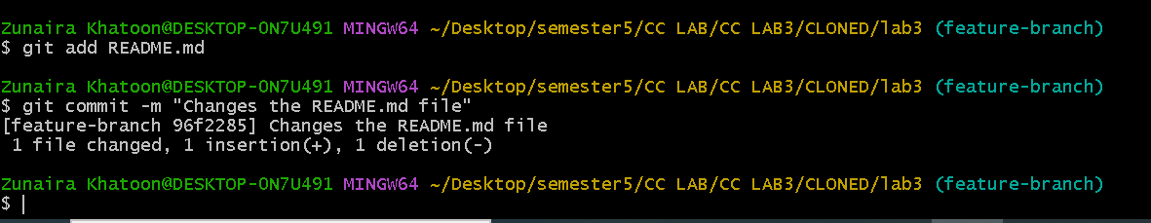
Step3&4
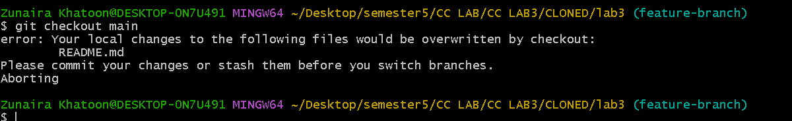
Step5
Step6
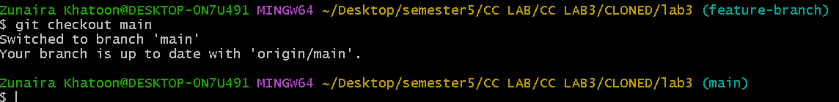
Step7
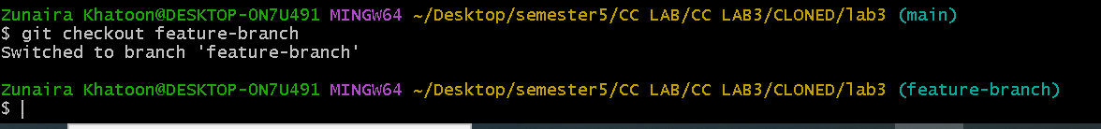
Step8
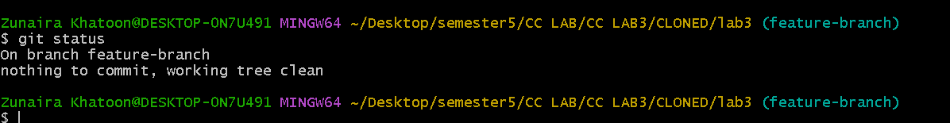
Step9
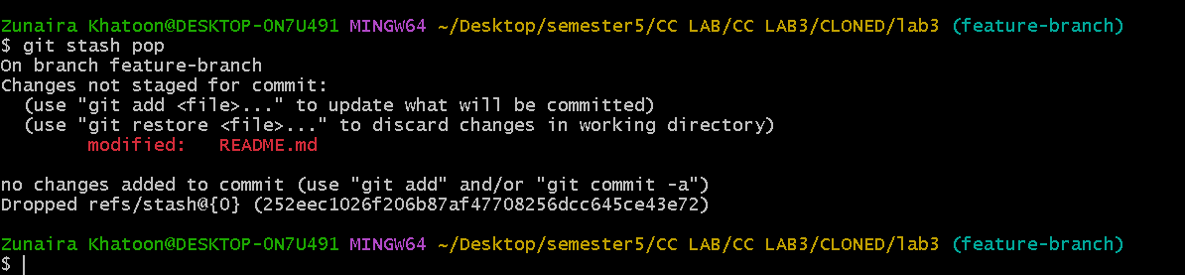
Task 5 – Checkout a Specific Commit Using git log
Step1
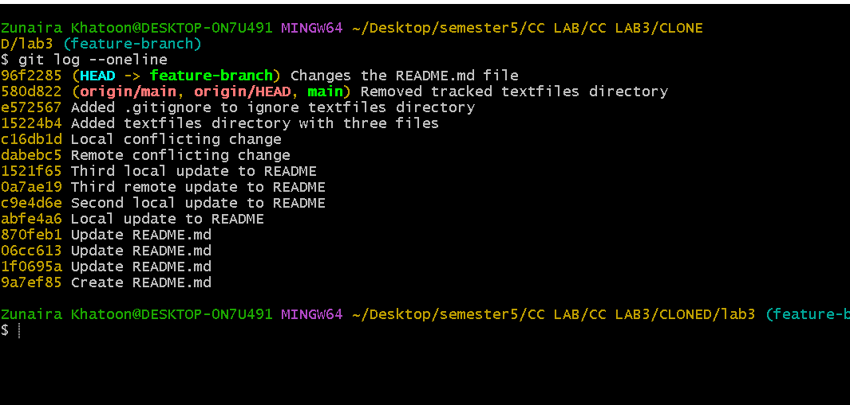
Step 2&3
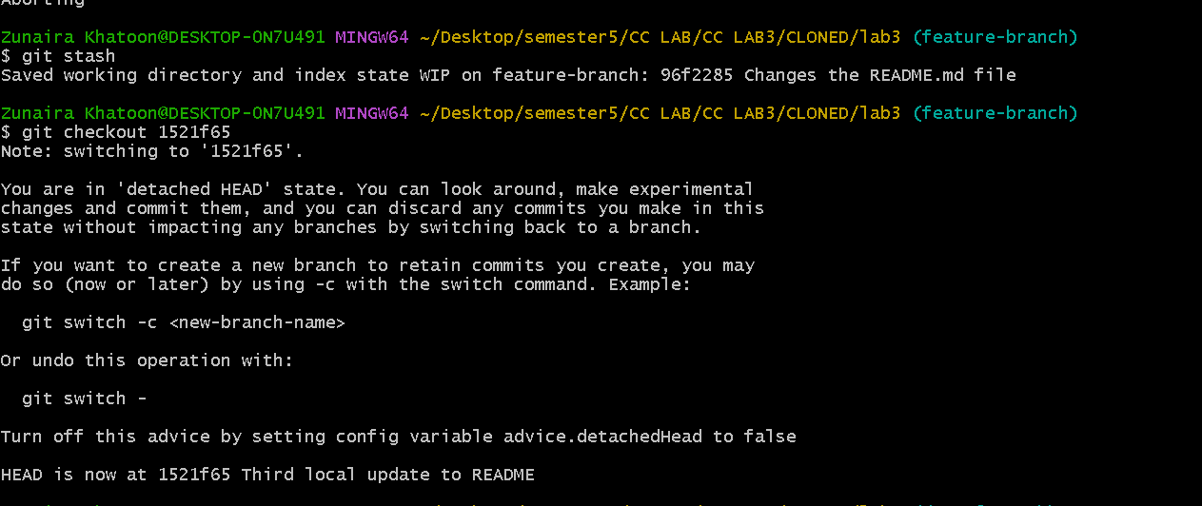
Step4
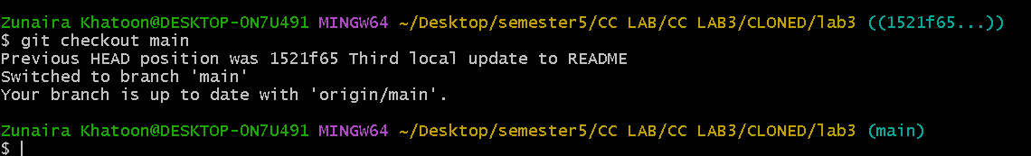
Task 6 – Resetting Commits (Soft vs Hard Reset) (With Verification Steps)
Step1
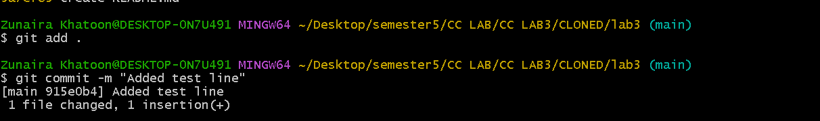
Step2
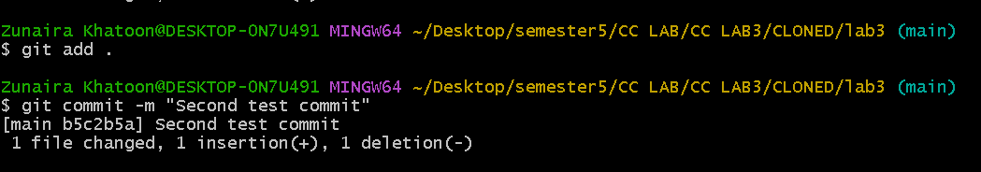
Step3
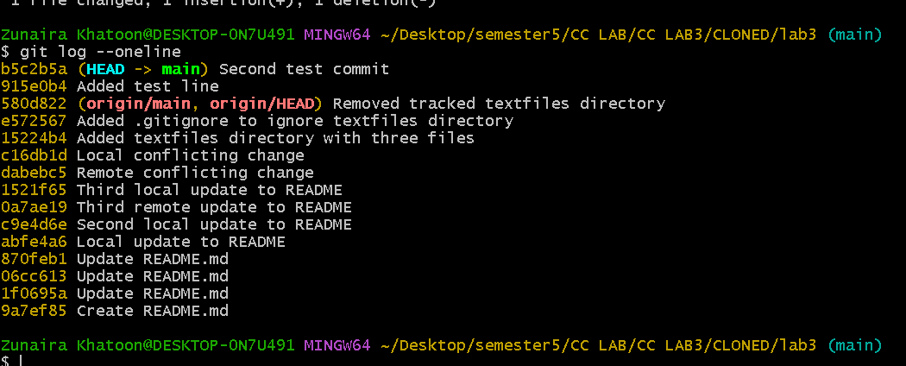
Step4
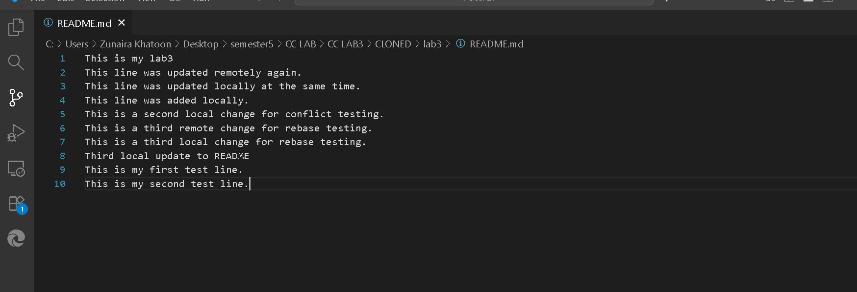
Step5
Step6
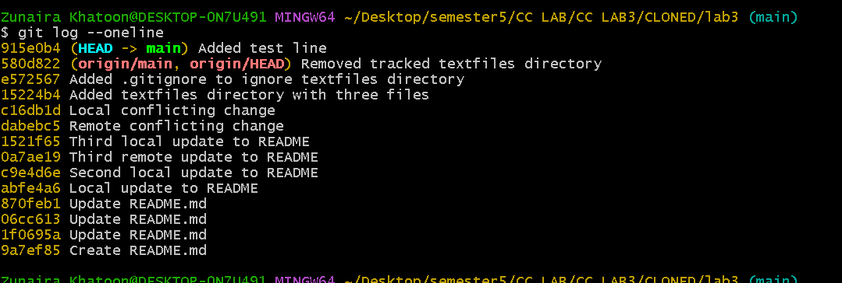
Step7
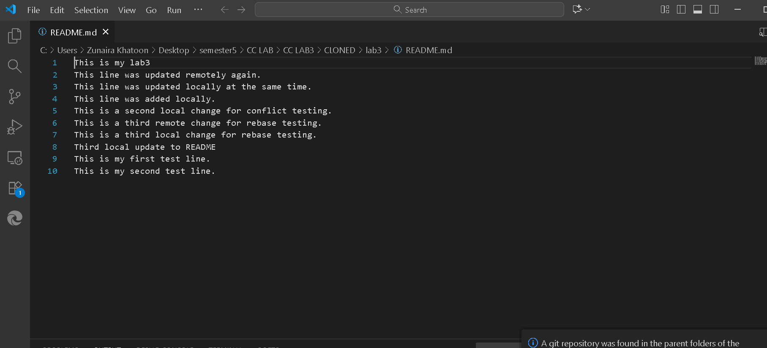
Step8
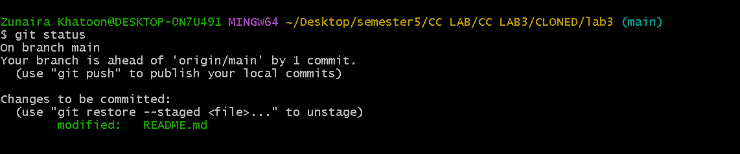
Step9
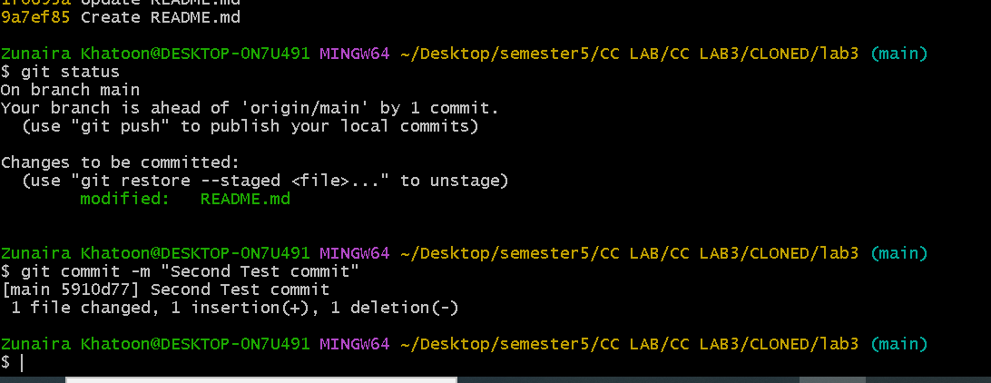
Step 10
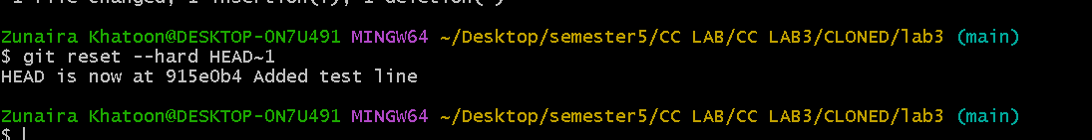
Step 11
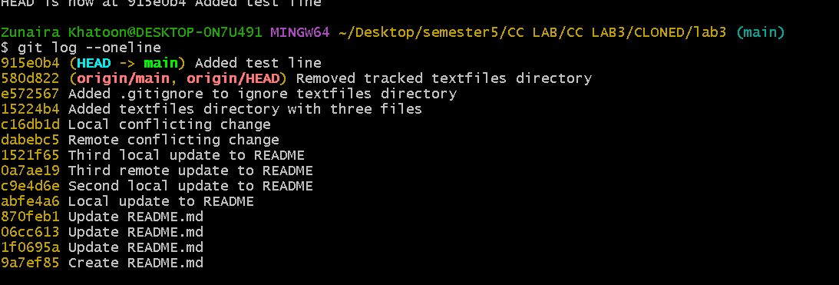
Step 12
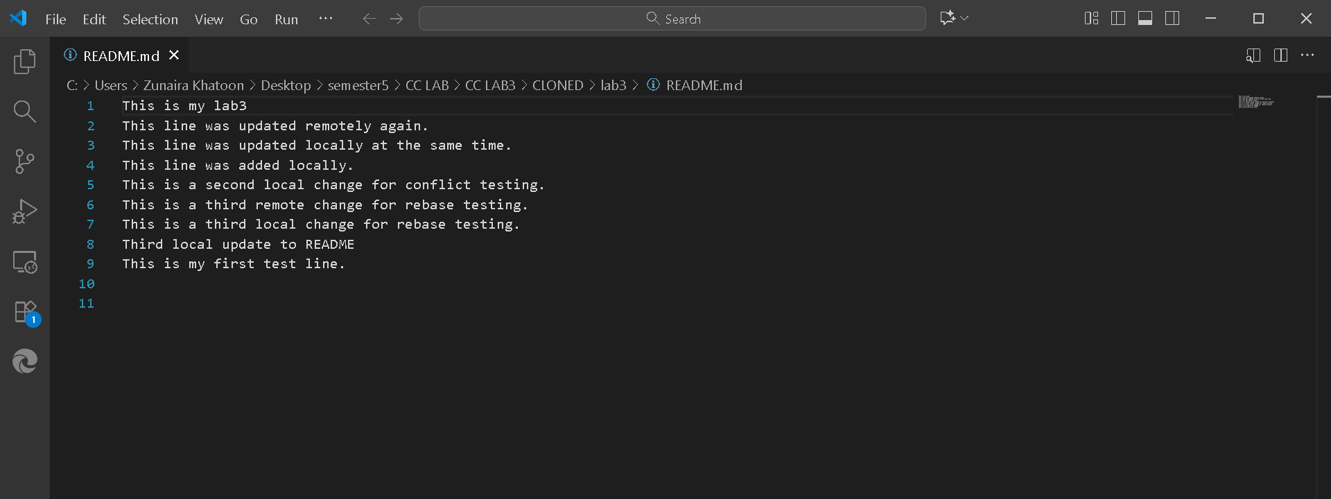
Step 13
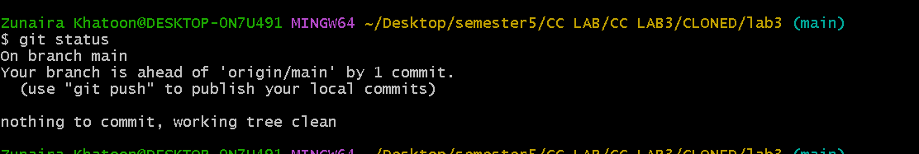
Task 7 – Amending the Last Commit
Step1
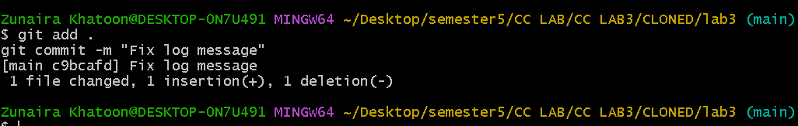
Step2
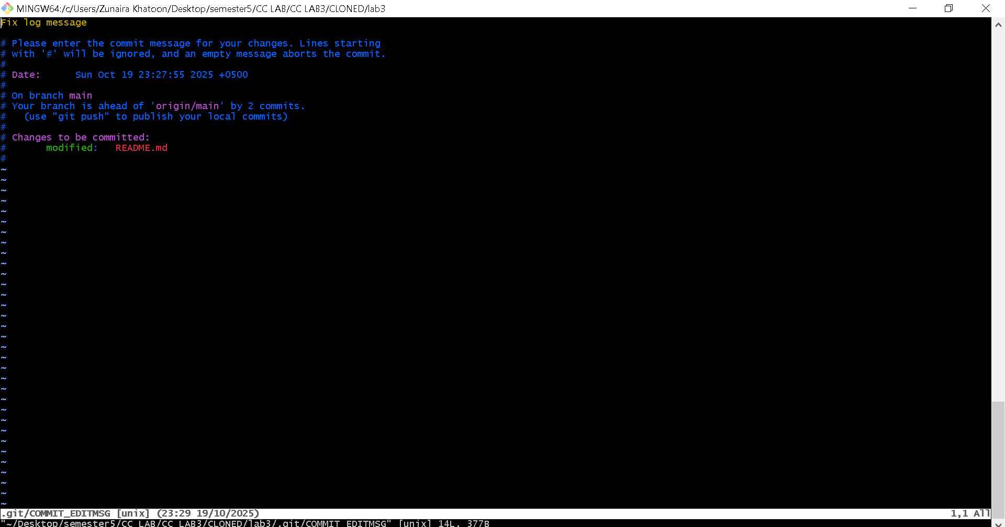
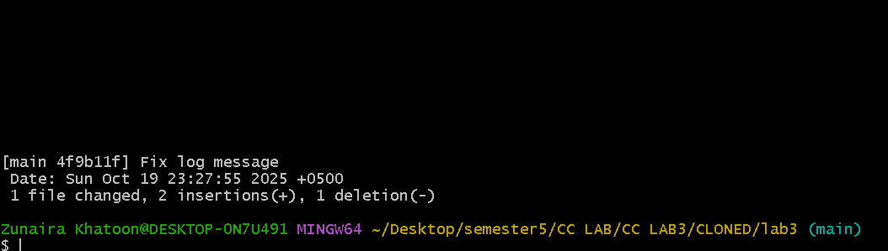
Task 8 – Reverting a Commit (Safe Undo on Remote Branch)
Step1
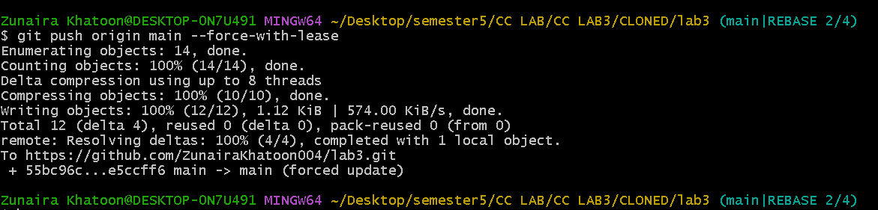
Step2
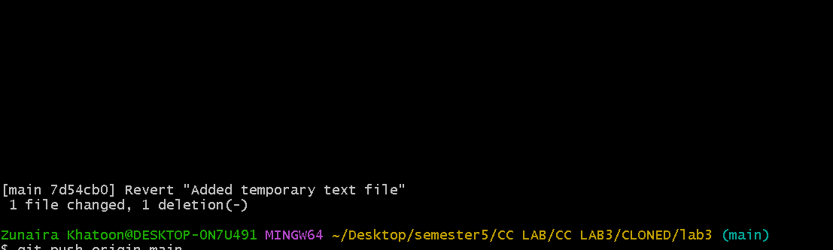
Step3
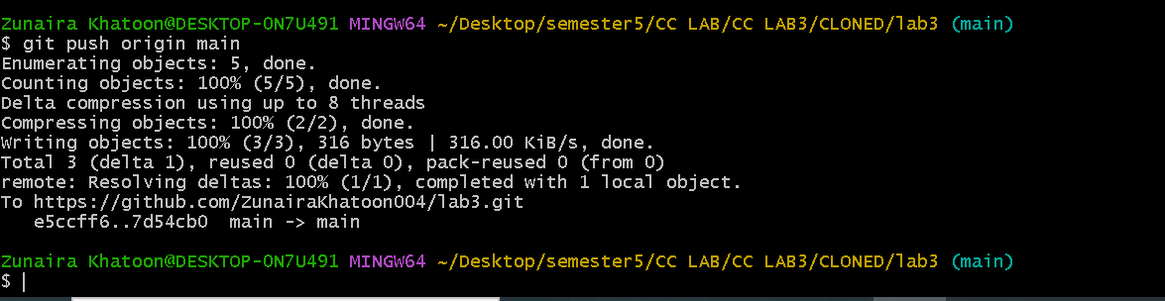
Task 9 – Force Push (With Caution)
Step1
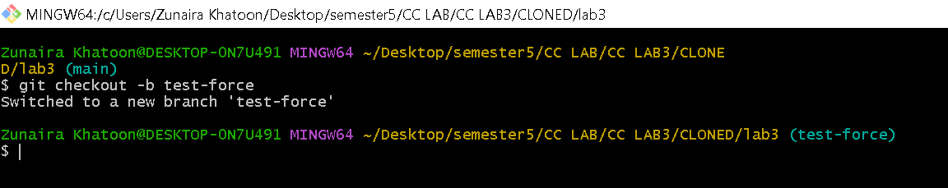
Step2
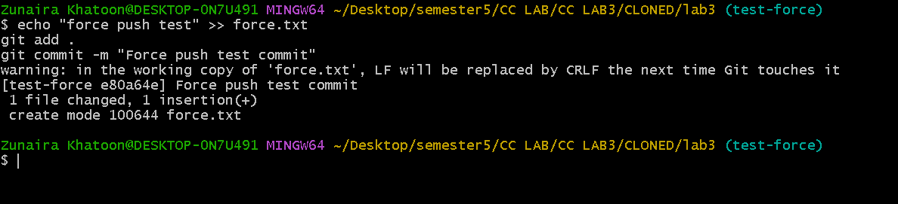
Step3
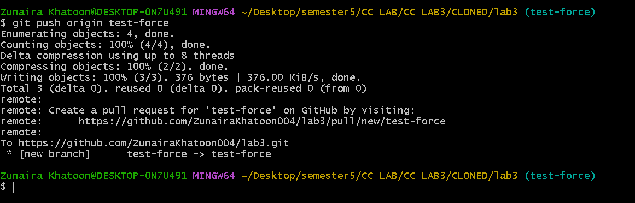
Step4
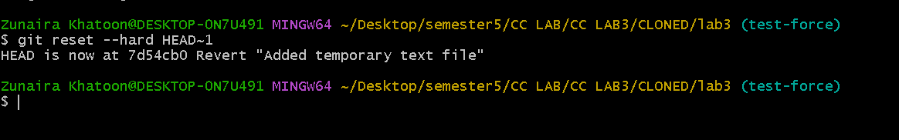
Step5
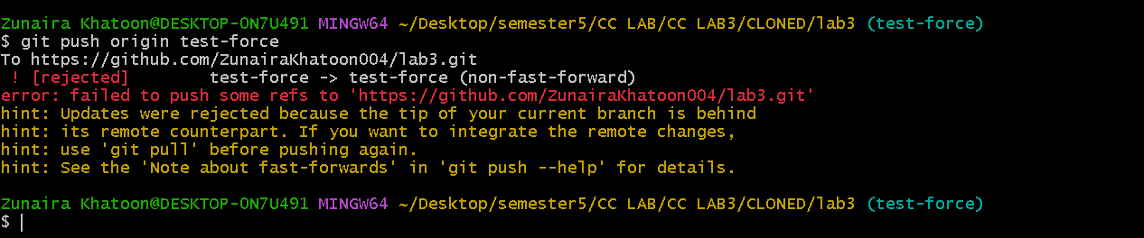
Step6
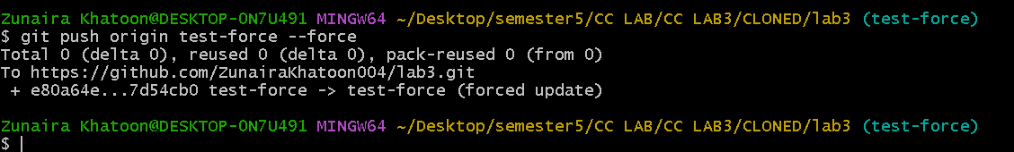

Task 10 – Running Gitea in GitHub Codespaces via Docker Compose
Step1
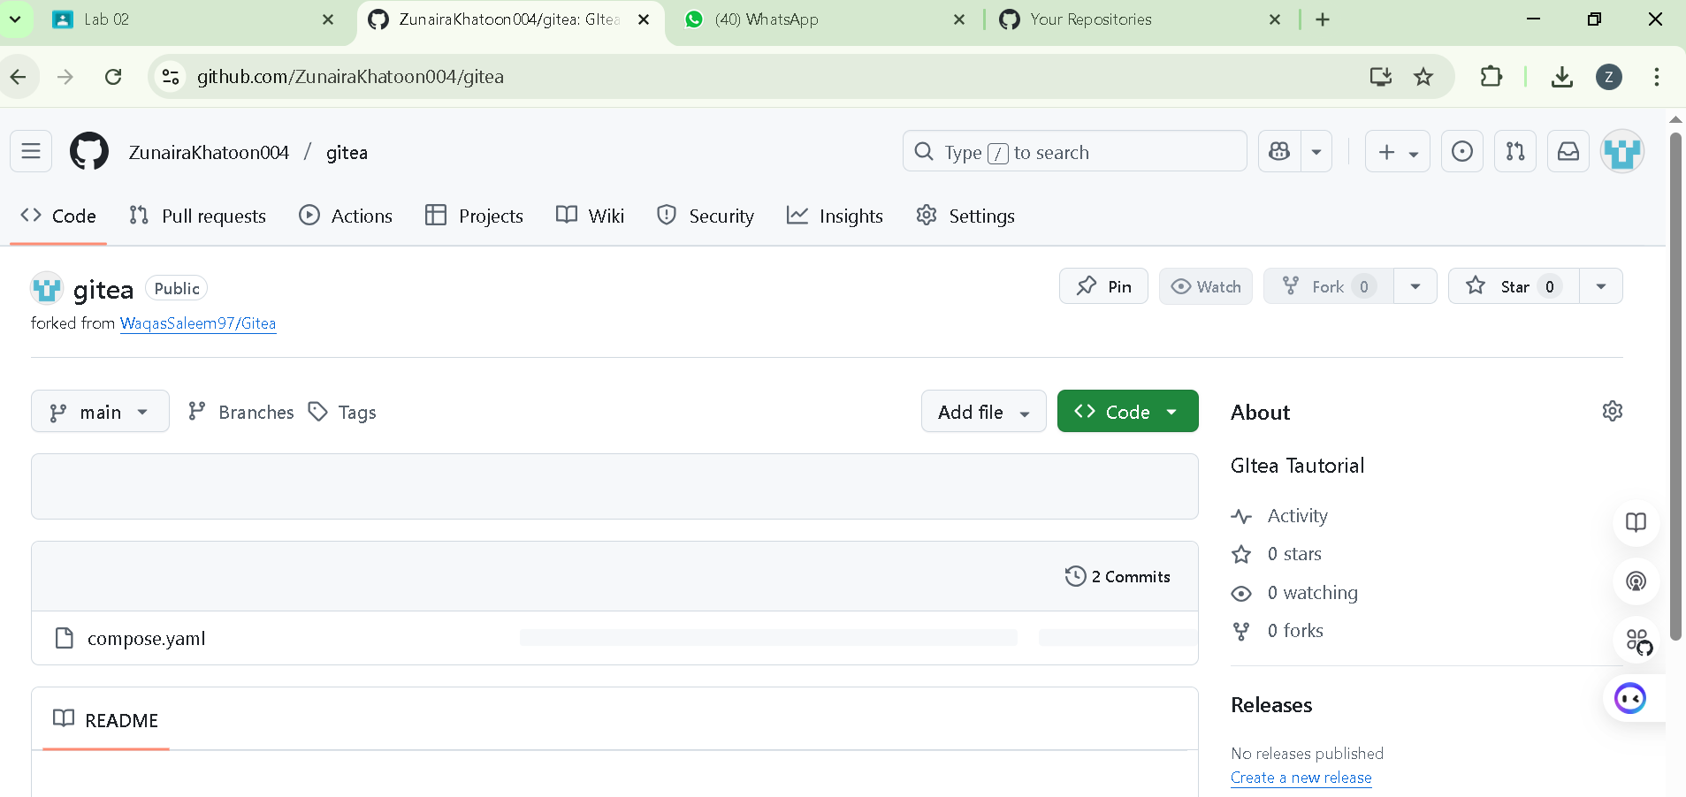

Step2
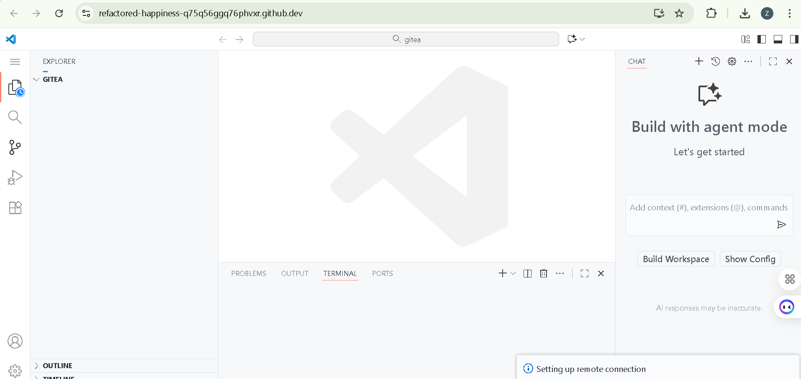
Step3
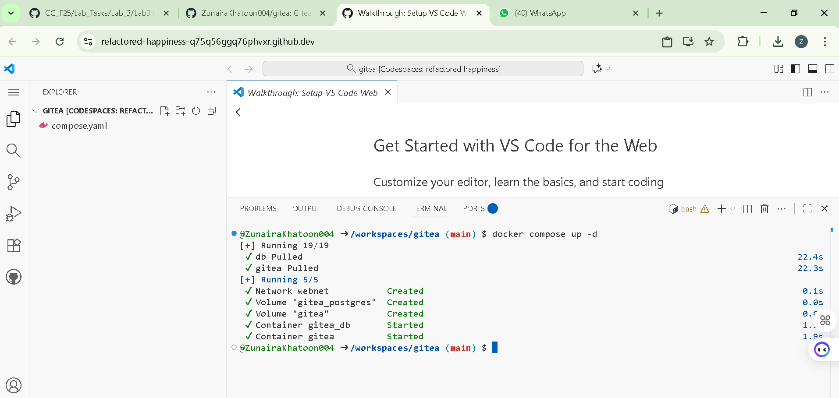
Step4
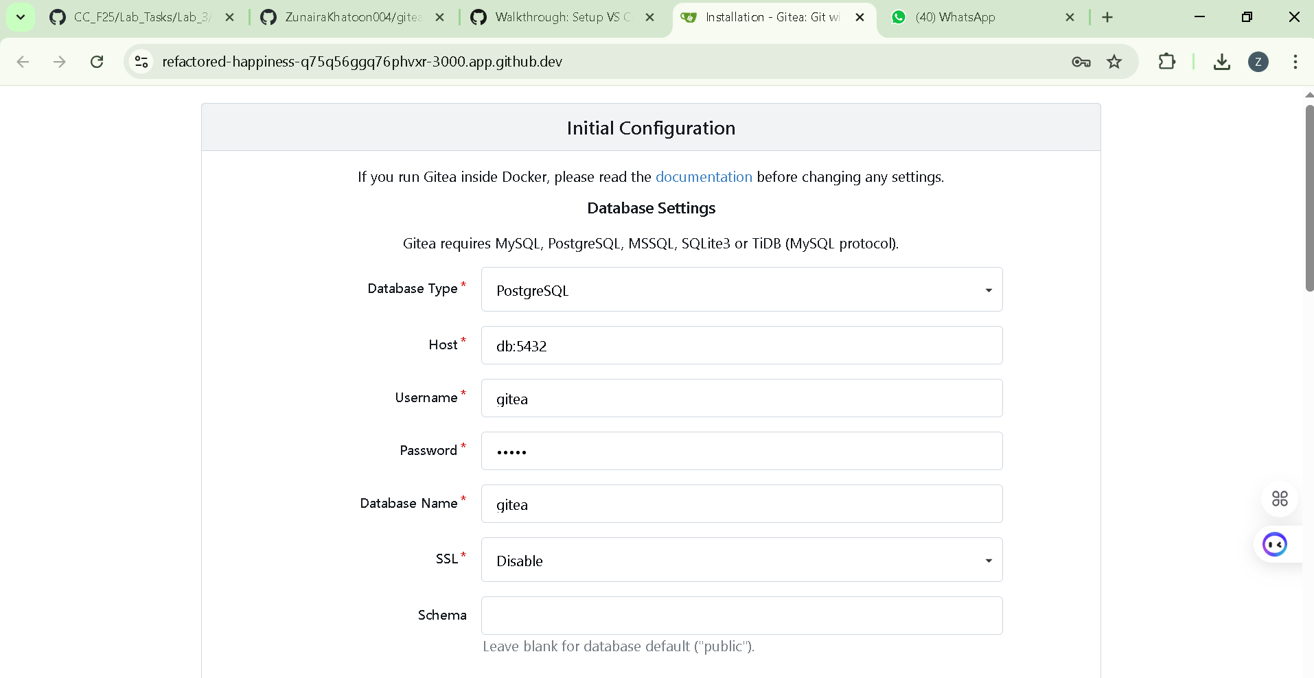
Step5&6
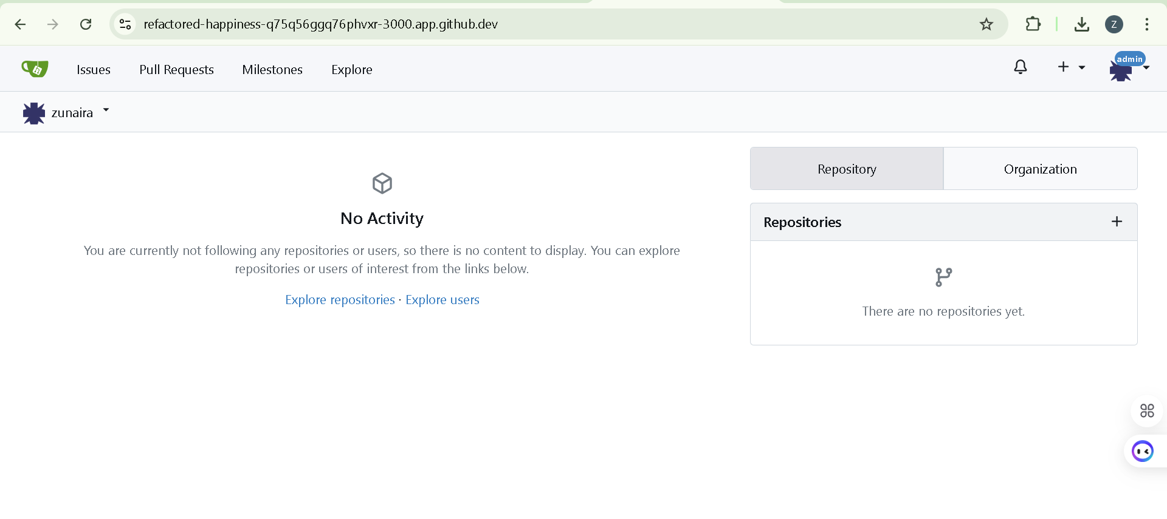
Step7
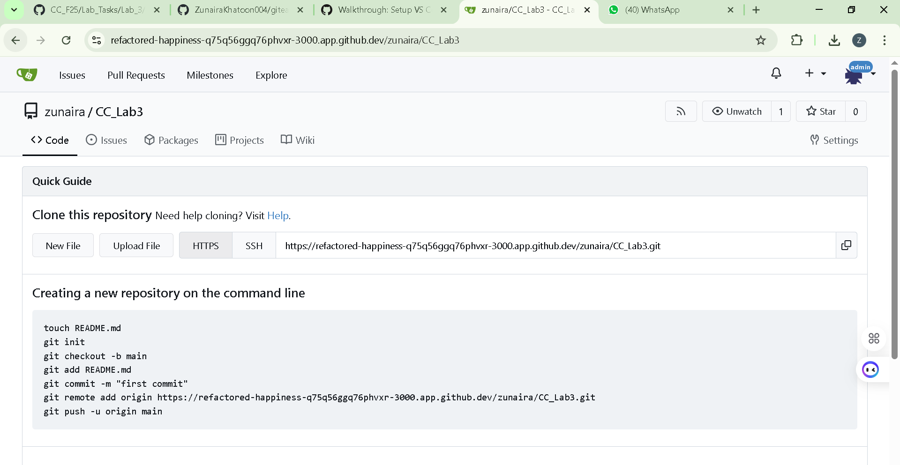
Task 11 – Creating a GitHub Pages Portfolio Site

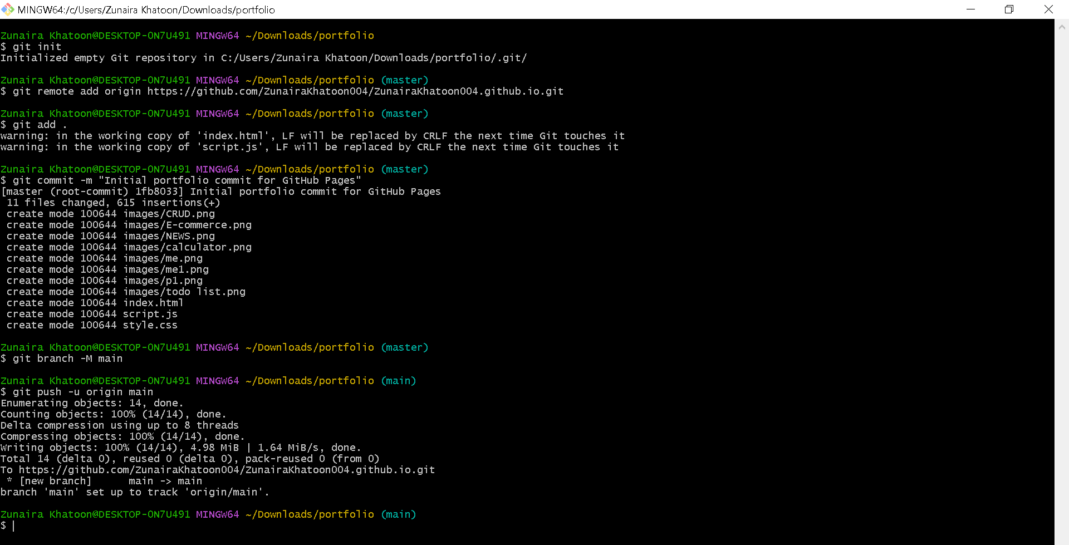
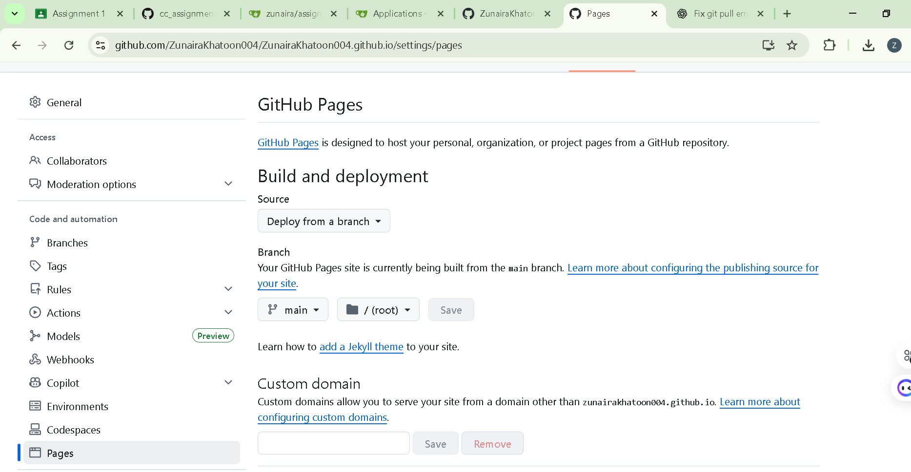
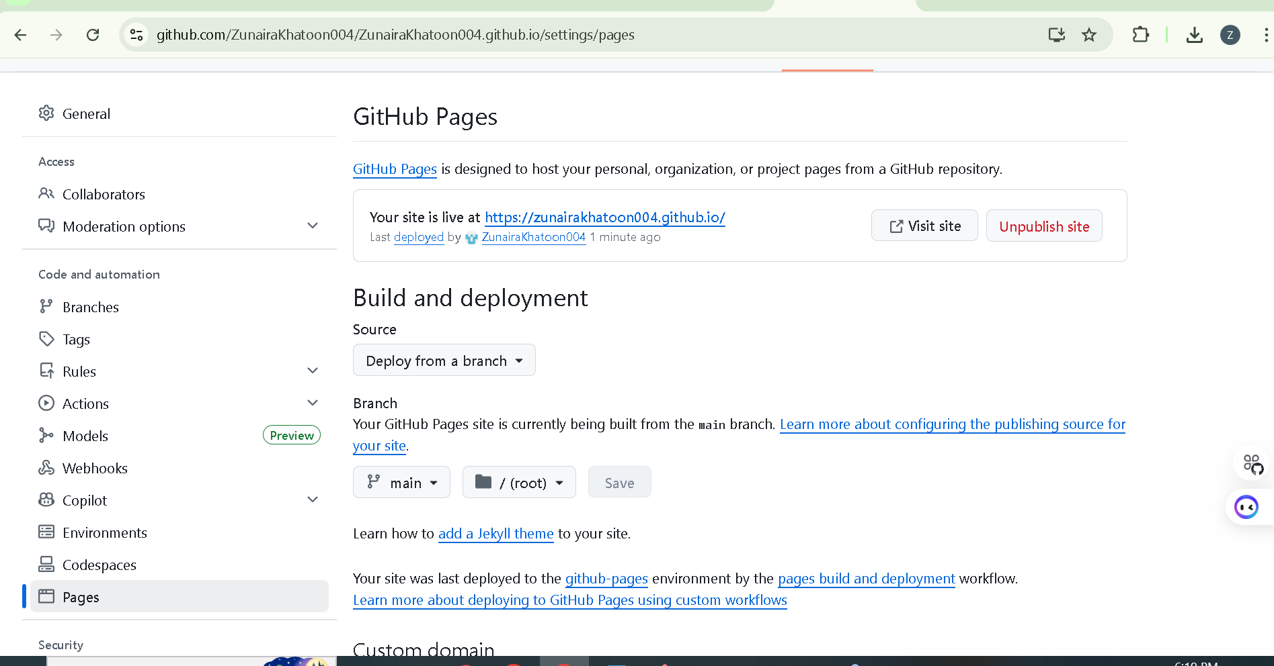

https://zunairakhatoon004.github.io/

